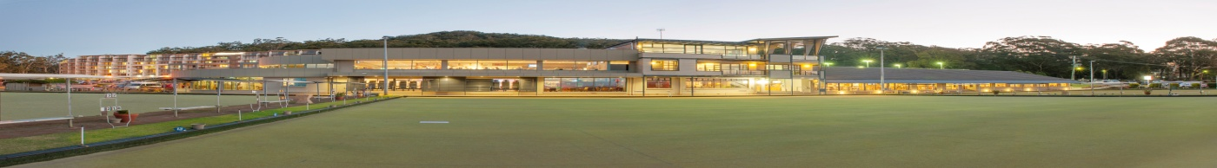
NELSON BAY BOWLING CLUB
2019 BLUEWATER MENS PAIRS
PROUDLY SPONSORED BY
GUY’S CHOICE CUTS
73 MAGNUS ST NELSON BAY 49811377
Monday 20th, Tuesday 21st, Wednesday 22nd MAY 2019
8 Games of 15 Ends, 3 x 3 Bowl Pairs, no dead ends Re-spotted Jack
3 Games Monday, 3 Games Tuesday and 2 Games Wednesday
An open draw will be held on Monday 20th May at 8.30am
Total Prize Money $10000.00
Tier 4 Bowls Australia Ranking Event
1st $3200.00 2nd $2400.00 3rd $1400.00 4th $1000.00 5th $600.00 6th $500.00 7th $400.00 8th $300.00
Plus the best cards in rounds 7 & 8 excluding major prize winners will receive $120.00
Entry Fee of $120.00 per team includes lunch each day
Please forward your entry along with method of payment to: RICHARD GIRVAN
P.O Box 210, Nelson Bay 2315 NSW or Email: bowls@nelsonbaybowlingclub.com.au Ph: 49811272 Fax: 49841670
LEAD………………………………………………………CLUB………………………………………….
SKIP…………………………………………..................CLUB…………………………………………..
Email…………………………………………………………..Ph……………………………………………

