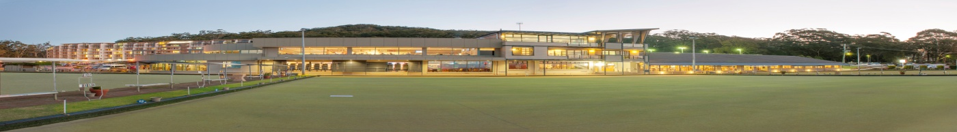

15TH – 19TH JULY 2019
Total Prize Money $5180.00

Name……………………………………………………………Phone………………………………………………
Email..………………………………………..................................Club..………………………………………

Mixed Fours Monday 15TH July: Entry Fee $80 per team includes lunch
1st $600 2nd $400 3rd $280 + Best Card in last round $200
LEAD | SECOND | THIRD | SKIP

Men’s Pairs Tuesday 16TH July: Entry Fee $40 per team includes lunch
1st $300 2nd $200 3rd $140 + Best Card in last round $100
LEAD | SKIP

Ladies Pairs Tuesday 16TH July: Entry Fee $40 per team includes lunch
1st $300 2nd $200 3rd $140 + Best Card in last round $100
LEAD | SKIP

Mixed Pairs Thursday 18TH July: Entry Fee $40 per team includes lunch
1st $300 2nd $200 3rd $140 + Best Card in last round $100
LEAD | SKIP

Mixed Fours Friday 19TH July: Entry Fee $80 per team includes lunch
1st $600 2nd $400 3rd $280 + Best Card in last round $200
LEAD | SECOND | THIRD | SKIP

3 GAMES OF 11 ENDS EACH DAY COMMENCING AT 9.00am
Please send entries and fees to:
Richard Girvan P.O. Box 210 Nelson Bay NSW 2315
bowls@nelsonbaybowlingclub.com.au Ph: 49811272

