**2023 Club Championship Ladies Division** 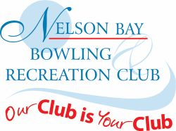

**Major Singles**

Winner – Bernie Carroll

Runner-up – Heather Witts

**Major pairs**

Winner – Jenice Brown & Bernie Carroll

Runner-up – Ann McCann & Helen Maloney

**Minor Singles**

Winner – Sue Clark

Runner-up – Leanne Murray

**Major Fours**

Winner – Pat Pepper, Leanne Murray, Sandra Swan, Toni Martin

Runner-up – Toni Shalders, Pam Pulbrook, Denise Archibald, Bernie Carroll

**Major Triples**

Winner – Helen Nicholls, Marion Dawson, Noreen Allen

Runner-up – Lin Hudson, Carol Saunders, Pat Pepper

**Mixed Fours**

Winner – Sue Clark, Sam Lurton, Ann McCann, Ray Read

Runner-up – Lin Hudson, Steve Wright, Toni Martin, Shaun Dumbrell

**Mixed Pairs**

Winners – Bernie Carroll & Chris Edmonds

Runner-up – Heather Witts & Lee Watson

**Ladies Player of the Year** – Bernie Carroll

**District Representative** – Bernie Carroll, Helen Maloney, Sue Clark