2023 Club Championship Ladies Division 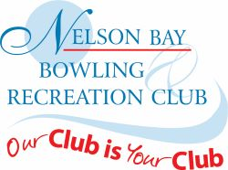
Major Singles
Winner – Bernie Carroll
Runner-up – Heather Witts
Major pairs
Winner – Jenice Brown & Bernie Carroll
Runner-up – Ann McCann & Helen Maloney
Minor Singles
Winner – Sue Clark
Runner-up – Leanne Murray
Major Fours
Winner – Pat Pepper, Leanne Murray, Sandra Swan, Toni Martin
Runner-up – Toni Shalders, Pam Pulbrook, Denise Archibald, Bernie Carroll
Major Triples
Winner – Helen Nicholls, Marion Dawson, Noreen Allen
Runner-up – Lin Hudson, Carol Saunders, Pat Pepper
Mixed Fours
Winner – Sue Clark, Sam Lurton, Ann McCann, Ray Read
Runner-up – Lin Hudson, Steve Wright, Toni Martin, Shaun Dumbrell
Mixed Pairs
Winners – Bernie Carroll & Chris Edmonds
Runner-up – Heather Witts & Lee Watson

Ladies Player of the Year – Bernie Carroll
District Representative – Bernie Carroll, Helen Maloney, Sue Clark

