2023 Club Championship Men’s Division 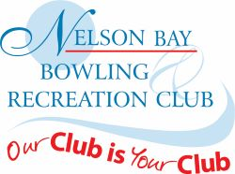
Major Singles
Winner – Richard Girvan
Runner-up – Jono Davis
Major pairs
Winner – Richard Girvan & Jono Davis
Runner-up – David Hall & Dave Walters
Minor Singles
Winner – David Hall
Runner-up – Ernie Ramsay
Minor Pairs
Winner – Sam Lurton & Alan Pulbrook
Runner-up – Lee Watson & Steve Wright
Major Fours
Winner – Kane Coulls, Steven Green, Jake Graham, Richard Girvan
Runner-up – Dennis McCann, Mark Rodway, Chris Rees, Ken Richardson
Major Triples
Winner – Des Allen, Dennis McCann, Kane Coulls
Runner-up – Peter Moxham, Chris Rees, Brendan Myers
Handicap Pairs
Winner – Darren Stewart & Mark Rice
Runner-up – Dennis McCann & Simon Wooster

Men’s Player of the Year – Jono Davis
Most Improved Player of the Year – Bruce Patchett
Zone Representatives – Jono Davis, Chris Edmonds, Kane Coulls
Zone 2022/23 Open Singles Winner – Jono Davis
Zone Senior Fours Winner – David Holmes, Ray Asquith, Russell Nobes, John Gibson
Zone Reserve Fours Winner – John Carroll, Kevin Kilbride, Brian Comley, Peter Mentis

