2024 Club Championship Ladies Division 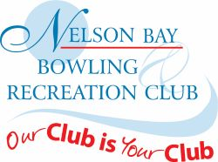
Major Singles
Winner – Pat Janes
Runner-up – Noreen Allen
Major pairs
Winner – Pam Pulbrook & Judy Eggert
Runner-up – Ann McCann & Helen Maloney
Minor Singles
Winner – Robyn Thompson
Runner-up – Heather Witts
Major Fours
DNP
Major Triples
DNP
Consistency Singles
Winner – Ann McCann
Runner-up – Sue Clark
Novice Singles
Winner – Stephanie Thorne
Mixed Fours
Winner – Toni Shalders, Bruce Patchett, Ann McCann, Peter Moxham
Runner-up – Jenice Brown, Steve Woods, Heather Witts, Alan Pulbrook
Mixed Pairs
Winners – Pat Janes & Chris Edmonds
Runner-up – Heather Witts & Glen Richard

Ladies Player of the Year – Ann McCann

